**“BEAUTY OF KONKAN:TOURISM WEBSITE”**

**A Project Report**

Submitted in partial fulfilment of the  
Requirement for the award of the Degree of

**BACHELOR OF SCIENCE (INFORMATION TECHNOLOGY)**

**By**

Mr. Vishal Shankar Parab.

**Under the esteemed guidance of**

**Mrs. Akshata Godakar**

**Assistant Professor**



**DEPARTMENT OF INFORMATION TECHNOLOGY**

**SHRI PANCHAM KHEMARAJ MAHAVIDYALAYA(AUTONOMUS)**

**(*AUTONOMUS*)**

**SAWANTWADI, 416510**

**MAHARASHTRA**

**2024-2025**

PROFORMA FOR THE APPROVAL PROJECT PROPOSAL

***(Note: All entries of the proforma of approval should be filled up with appropriate and complete information. Incomplete proforma of approval in any respect will be summarily rejected.)***

**PRN No. 2023016401956424 Roll No. ____________**

1. **Name of the Student**

**Mr. Vishal Shankar Parab**

1. **Title of the Project**

**Beauty of Konkan:tourism Website**

1. **Name of the Guide**

**Mrs. Akshata Godakar**

1. **Teaching experience of the Guide**
2. **Years**
3. **Is this your first submission? Yes No**

**Signature of the Student Signature of the Guide**

**Date: …………. Date: ………….**

**Signature of the coordinator**

**Date: ………….**

**SHRI PANCHAM KHEMRAJ MAHAVIDYALAYA  
*(Affiliated to University of Mumbai)*SAWANTWADI-MAHARASHTRA-416510**

**DEPARTMENT OF INFORMATION TECHNOLOGY**



**CERTIFICATE**

This is to certify that the project entitled, "**Beauty of Konkan:Tourism Website**", is bonafied work of **Mr. Vishal Shankar Parab** bearing Seat No: submitted in partial fulfillment of the requirements for the award of degree of BACHELOR OF SCIENCE in INFORMATION TECHNOLOGY from University of Mumbai.

**Internal Guide Coordinator**

**External Examiner**

**Date: College Seal**

**Role and Responsibility**

In this project, the following roles and responsibilities were undertaken:

Mr. Vishal Shankar Parab

Role: Project Leader

* Oversee project planning, track progress, and ensure timely booking.
* Design and implement the backend system using Php, manage database connections, and handle server-side logic.
* Develop and maintain the user interface using HTML, CSS Ensure mobile responsiveness and usability.
* Design database schema, manage database servers, and ensure data integrity and security.
* Design and execute test cases, perform unit and integration testing, and report bugs.

**ABSTRACT**

Konkan, a coastal stretch along the western coastline of India, is renowned for its natural beauty, cultural heritage, and serene landscapes. This project aims to explore and present the unique attractions of Konkan tourism through a dedicated website. The project focuses on highlighting the pristine beaches, historical forts, traditional cuisine, lush greenery, and vibrant festivals that make Konkan a sought-after tourist destination.

The website is designed to serve as an informative and engaging platform for tourists, providing them with detailed insights into the best destinations, travel tips, and local experiences. It includes features such as interactive maps, photo galleries, and sections for popular tourist spots like Ratnagiri, Alibaug, Ganpatipule, and Sindhudurg. Additionally, the website offers an easy-to-navigate interface, ensuring a user-friendly experience.

This project combines modern web design techniques with a content-rich approach to promote Konkan as an ideal location for both adventure seekers and those looking for a peaceful retreat. The use of responsive design ensures accessibility across devices, making the website a convenient tool for tourists planning their trip to this beautiful region.

Overall, the project serves as a comprehensive guide to Konkan tourism, aiming to boost tourism and create awareness of the region's hidden gems.

**ACKNOWLEDGEMENT**

I feel proud in presenting my project report of **“Beauty of Konkan : Tourism Website”.** This project has been complete successfully for Sem III according to syllabus copy under guidance of **Mrs. Akshata Godakar**

I am also thankful to our principal **Dr. D. L. Bharmal** for providing necessary facilities. I wish to thanks for his valuable guidance. I convey my hearty gratitude to our Head of the Department **Mrs. Akshata Satardekar**. For his sincere co-operation. I also thanks to all professor for their sincere guidance.

I am so thankful to all my friend who supported me to Completing my project.

Thank you …

Developed by

**Vishal Shankar Parab**

SY BSC Information Technology

**DECLARATION**

I hereby declare that the project entitled, **“Beauty Of Konkan:tourism Website”** done at **Shree Pancham Khemraj Mahavidyalaya Sawantwadi (AUTONOMUS)**, has not been in any case duplicated to submit to any other university for the award of any degree. To the best of my knowledge other than me, no one has submitted to any other university.

The project is done in partial fulfillment of the requirements for the award of degree of

**(BACHELOR OF SCIENCE (INFORMATION TECHNOLOGY)** to be submitted

as final semester project as part of our curriculum.

**(Mr. Vishal Shankar parab)**

**TABLE OF CONTENTS**

|  |  |  |  |  |
| --- | --- | --- | --- | --- |
| **Sr. No.** | **Chapter No.** | **Title** | | **Page No.** |
| **1** | **1** | **INTRODUCTION** | |  |
|  | **1.1** | Background | |  |
|  | **1.2** | Objectives | |  |
|  | **1.3** | Purpose and Scope | |  |
|  |  | **1.3.1** | Purpose |  |
|  |  | **1.3.2** | Scope |  |
|  |  | **1.3.3** | Applicability |  |
| **2** | **2** | **SURVEY OF TECHNOLOGIES** | |  |
|  |  | **2.1** | HTML & CSS |  |
|  |  | **2.2** | JavaScript |  |
| **3** | **3** | **REQUIMENT AND ANALYSIS** | |  |
|  | **3.1** | Problem Defination | |  |
|  | **3.2** | Planning and Scheduling | |  |
|  | **3.3** | Software and Hardware Requirements | |  |
| **4** | **4** | **SYSTEM DESIGN** | |  |
|  | **4.1** | Basic Model (ER Diagram) | |  |
|  | **4.2** | DataDesign | |  |
|  |  | **4.2.1** | Class Diagram |  |
|  |  | **4.2.2** | Use-Case Diagram |  |
|  |  | **4.2.3** | Sequence Diagram |  |
|  |  | **4.2.4** | Activity Diagram |  |
|  |  | **4.2.5** | Date Flow Diagram |  |
|  |  | **4.2.6** | Component Diagram |  |
|  | **4.3** | User Interface Design | |  |
|  | **4.4** | Test Case Design | |  |
| **5** | **5** | **IMPLEMENTATION** | |  |

|  |  |  |  |  |
| --- | --- | --- | --- | --- |
| **Sr. No.** | **Chapter No.** | **Title** | | **Page No.** |
|  | **5.1** | Coding Details | |  |
| **6** | **6** | **RESULTS** | |  |
|  | **6.1** | TEST REPORTS | |  |
| **7** | **7** | **CONCLUSION** | |  |
|  | **7.1** | Conclusion | |  |
|  |  | **7.1.1** | Significance of the System |  |
|  | **7.2** | Limitation of the system | |  |
|  | **7.3** | Future scope of the project | |  |
| **8** | **8** | **REFERENCES** | |  |
|  | **8.1** | Reference | |  |

# **Chapter 1 Introduction**

The Konkan region, nestled along the western coastline of India, is renowned for its breathtaking natural beauty, pristine beaches, lush green landscapes, and rich cultural heritage. Stretching from the coastal states of Maharashtra, Goa, and Karnataka, Konkan has emerged as one of the most sought-after destinations for both domestic and international travelers. The region’s picturesque scenery, tranquil backwaters, diverse flora and fauna, and historical landmarks contribute to its growing popularity in the tourism sector.

This mini project, titled "The Beauty of Konkan Tourism", aims to explore the key attractions, natural beauty, cultural significance, and tourist experiences that make Konkan a unique travel destination. Through this project, we will examine the various tourism hotspots, such as the serene beaches of Alibaug, the historic forts of Sindhudurg, and the vibrant traditions of Goa. Additionally, this report provides insights into the region’s eco-tourism potential and how sustainable practices can enhance the tourism experience while preserving Konkan's fragile ecosystems.

This report is structured to highlight the geographical overview of Konkan, followed by an in-depth look at its tourist attractions, cultural festivals, local cuisine, and economic impact on the region. With the growing interest in coastal tourism and eco-friendly travel, the Konkan region holds immense potential for further development as a premier tourist destination.

**1.1Background:**

Konkan, a picturesque coastal region in western India, stretches along the Arabian Sea and encompasses the states of Maharashtra, Goa, and Karnataka. Renowned for its breathtaking landscapes, pristine beaches, lush green hills, and rich cultural heritage, Konkan attracts tourists seeking both adventure and tranquility. The region is dotted with charming fishing villages, ancient forts, and vibrant local markets, providing a unique blend of natural beauty and cultural experiences. Konkan's diverse ecosystem, characterized by its dense forests, cascading waterfalls, and vibrant flora and fauna, makes it a haven for nature enthusiasts and wildlife lovers. The local cuisine, featuring delectable seafood and regional specialties, further enhances the appeal of this coastal paradise. As awareness of sustainable tourism grows, the potential for Konkan to emerge as a prominent tourist destination is significant, promising both economic development and the preservation of its cultural and environmental treasures. This project aims to highlight the beauty and potential of Konkan tourism, exploring its key attractions, cultural richness, and the importance of responsible travel practices to ensure its longevity for future generations.

**1.2 Objectives:**

**Here some objectives of Website: -**

The primary objective of this project is to design and develop a user-friendly and visually appealing website that promotes tourism in the Konkan region. The website will showcase the natural beauty, cultural heritage, and tourist attractions of Konkan, with the aim of providing comprehensive information to potential travelers. This includes:

* **Highlighting Key Destinations**: Offering detailed descriptions of popular tourist spots, such as beaches, temples, historical sites, and scenic landscapes.
* **Travel Guides and Tips**: Providing practical information for travelers, such as accommodation, transportation options, and recommended itineraries.
* **Interactive Features**: Incorporating user-friendly features like maps, photo galleries, and testimonials to enhance user experience.
* **Boosting Local Tourism**: Promoting local businesses, handicrafts, and cultural experiences, thereby supporting the local economy.
* **Mobile Responsiveness**: Ensuring that the website is accessible on all devices, including desktops, tablets, and smartphones.
* **Environmental** Awareness: Encouraging sustainable and eco-friendly tourism practices to preserve the natural beauty of the Konkan region for future generations.

.

**1.3.1 Purpose:**

* The purpose of this project is to develop a comprehensive website that showcases the beauty and tourism potential of the Konkan region. The primary objectives include:
* Promotion of Konkan Tourism: To highlight the scenic locations, cultural heritage, and attractions in the Konkan region, thereby promoting tourism and attracting visitors from across the world.
* User-Friendly Information Source: To provide a user-friendly platform where travelers can easily access detailed information on various tourist spots, accommodations, travel guides, and local cuisines in Konkan.
* Increased Awareness of Local Culture: To enhance awareness about the rich and diverse cultural traditions of the Konkan region, including festivals, crafts, and historical significance.
* Support for Local Economy: By promoting local attractions, the website aims to support local businesses such as hotels, restaurants, tour operators, and artisans, contributing to the economic growth of the region.
* Interactive Features: To incorporate interactive features such as feedback forms, itinerary planners, and contact information for tourism support to ensure a better user experience and engagement.
* Sustainable Tourism: To encourage responsible and sustainable tourism practices, focusing on eco-friendly travel options and preservation of natural resources.
  + 1. **Scope:**

The "Beauty of Konkan Tourism" website aims to provide a comprehensive platform for showcasing the unique attractions, natural beauty, and cultural richness of the Konkan region. The primary goal of the project is to promote tourism by offering valuable information to travelers, including details on tourist destinations, local cuisine, festivals, historical landmarks, and adventure activities. The website will serve as an easy-to-navigate guide for both domestic and international tourists interested in exploring the scenic coastal landscapes and hidden gems of Konkan.

* + 1. **Applicability:**
* Promotion of Local Tourism: The website serves as a digital guide, making it easier for tourists to explore Konkan without the need for physical guides.
* Accessible Information: A well-structured website allows visitors to discover information about places of interest, accommodations, transportation, and local culture.
* Business Opportunities: Helps local businesses, hotels, and tour operators get visibility by featuring their services.
* Environmental Awareness: The website can include responsible tourism practices and promote eco-friendly travel options.
* Educational Tool: The website can serve educational purposes, providing students or researchers with insights into Konkan’s geography, history, and culture.

**CHAPTER 2**

**SURVEY OF TECHNOLOGY**

**Required Tools for analysis:**

**2 .1Front-end languages :**

Front-end means languages that used for user interface and designing and coding. According to project requirement I select HTML, CSS , JavaScript as Front-end for developing my project.

**2.2Back-end languages:**

The Back end refers to the server-side of the Web-application or software, where data processing, storage, logic take place. Its responsible for handling requests from the frontend, interacting with databases, executing server-side logic, and sending response back to the client. According to project requirement I select PHP , MYSQL database.

**2.1.1HTML:**

HTML stands for Hypertext Markup Language. It is the standard language used to create web pages and web applications. HTML provides a structure for content and allows web designers to create websites that can be rendered by web browsers. HTML uses markup tags to define the content and structure of a web page.

**2.1.2CSS:**

CSS stands for Cascading Style Sheets. It is a style sheet language used to describe the presentation of a document written in HTML or XML. CSS is used to define the style, layout, and design of web pages, allowing web designers to create visually appealing and responsive websites.

**2.1.3JavaScript:**

JavaScript is a programming language that is commonly used in web development to create dynamic and interactive web pages. It is a client-side scripting language, which means that it runs on the user's web browser rather than on the web server. JavaScript allows web developers to add interactivity to web pages by manipulating the Document Object Model (DOM), which is the programming interface for HTML and XML documents.

**2.2.1MySQL:**

MySQL is an open-source relational database management system that allows users to store, organize and manage data. It uses a structured query language for interacting with databases and is commonly used for web development to handle data- driven task. MySQL is known for its reliability, ease of use and wide adoption in various applications and industries.

**CHAPTER 3**

**REQUIMENT AND ANALYSIS**

**3.1: Problem Definition:**

Tourism is a key factor in promoting regional culture, history, and natural beauty. The Konkan region, with its picturesque beaches, lush greenery, historical landmarks, and vibrant local traditions, is an ideal destination for both domestic and international tourists. However, there is a lack of an accessible, user-friendly platform that comprehensively showcases all the attractions, accommodations, and services available in the region. The challenge is to create a website that not only promotes Konkan's tourism potential but also provides practical and valuable information to travelers, such as details about tourist spots, transport, accommodations, local food, and cultural experiences.

Many travelers find it difficult to plan their trips due to fragmented information scattered across various sources. Existing tourism websites are often outdated or cluttered, lacking an appealing interface or a mobile-responsive design that modern users expect. Additionally, there is a need to highlight lesser-known spots and eco-friendly tourism practices to encourage sustainable travel to the region.

This project aims to develop an informative, visually appealing, and easy-to-navigate website that promotes the beauty of Konkan. The website will provide essential details about top destinations, itineraries, accommodations, local businesses, and cultural highlights. By offering up-to-date, comprehensive information, the website will enhance the travel experience and contribute to the growth of tourism in the Konkan region.

4o

**3.2 Planning and Scheduling:**

The *Beauty of Konkan Tourism* website project was meticulously planned and scheduled to ensure timely completion and high-quality output. Initially, the project was divided into distinct phases, including research, design, content creation, development, and testing. The planning phase involved in-depth research on Konkan's key tourist attractions, local culture, and historical significance. Once the research was completed, the design phase focused on creating a user-friendly interface that would capture the essence of the region's natural beauty and heritage. The content creation phase included the development of engaging text and multimedia content to highlight destinations such as beaches, forts, temples, and biodiversity hotspots.

The scheduling process followed a structured timeline, with each phase assigned specific deadlines. Weekly meetings were held to review progress, address challenges, and adjust the timeline when necessary. The development and testing phases were scheduled in parallel to allow for iterative improvements and ensure that the website functioned smoothly across devices. The final product was completed within the estimated timeframe, with the flexibility to accommodate last-minute updates based on feedback from team members and users.

**Gantt Chart:**

**Actual**

**Planned**

|  |  |  |  |  |
| --- | --- | --- | --- | --- |
|  | **July** | **Aug** | **Sep** | **Oct** |
| **Planning** |  |  |  |  |
| **Research** |  |  |  |  |
| **Design** |  |  |  |  |
| **Implementation** |  |  |  |  |
| **Testing** |  |  |  |  |

**3.4: Software and Hardware Requirements:**

* **Hardware Requirements:**

1. Processor: AMD Ryzen 5 7520U with Radeon Graphics 2.80 GHz

2. RAM: 8 GB

3. Storage: 512 GB SSD

6. *Other Peripherals*:

- Mouse and Keyboard

- Monitor

- Internet Connection (for online functionalities)

* **Software Requirements:**

1. Operating System: Windows 10

2. Development Tools: Visual Studio code,Notepad

3. Programming Languages: HTML

4. Database: MySQL

5. Version Control: 23H2

6.Supporting Server **:** APACHE Server (XAMPP Control Panel)

7. Browser: Google Chrome, Internet Explorer

**CHAPTER 4**

**SYSTEM DESIGN**

**4.1 Basic Model ER Diagram**

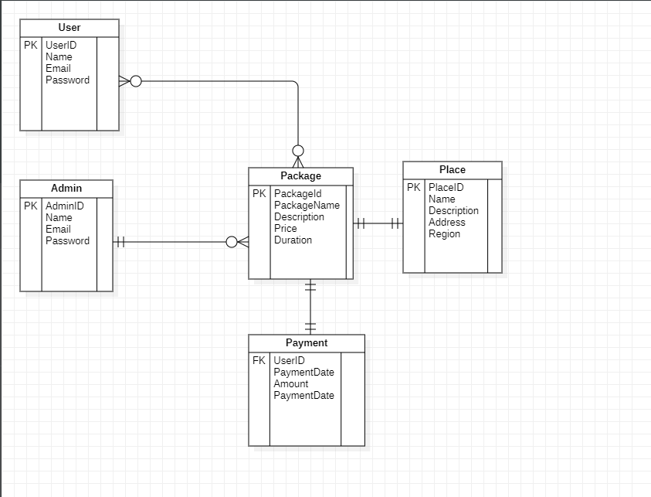

4.1 Entity Relationship Diagram

Entity relationship diagram is a specialized graphics that illustrates the interrelationship between in a database. In a er diagram uses symbol to represent the different type of information.

**4.2 DATA DESIGN**

**4.2.1 Class Diagram:**

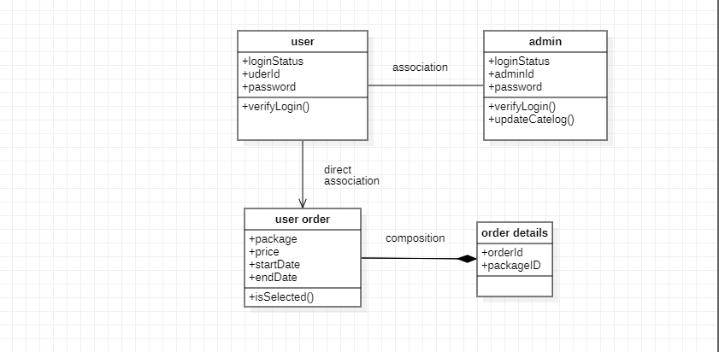

**4.2.2 Use-Case Diagram:**

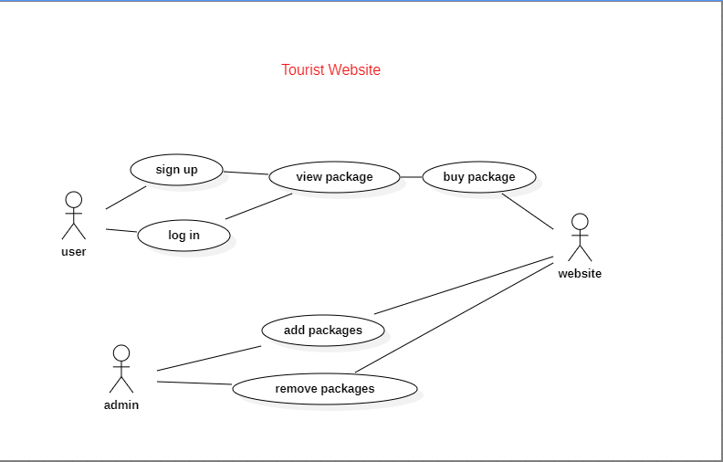

**4.2.3 Sequence Diagram:**

**For Signup and Login:**

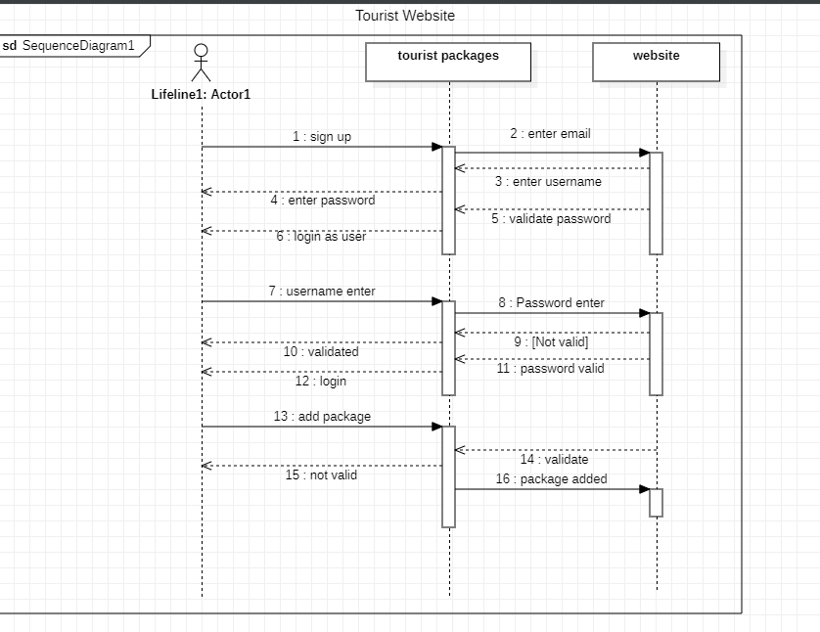

**4.2.4 Activity Diagram:**

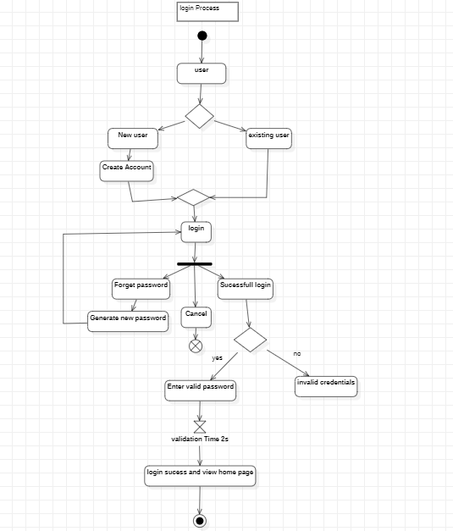

**4.2.5 Data Flow Diagram:**

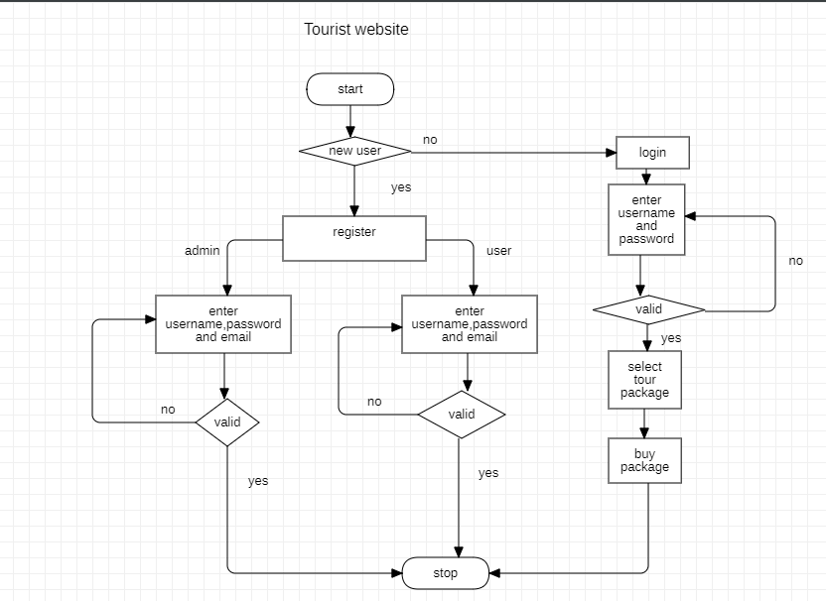

* + 1. **Component Diagram:**

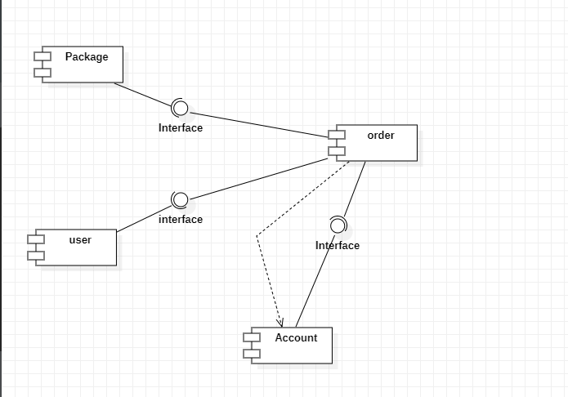

**CHAPTER 5**

**IMPLEMENTATION**

**5: User Interface Design:**

**Login :**

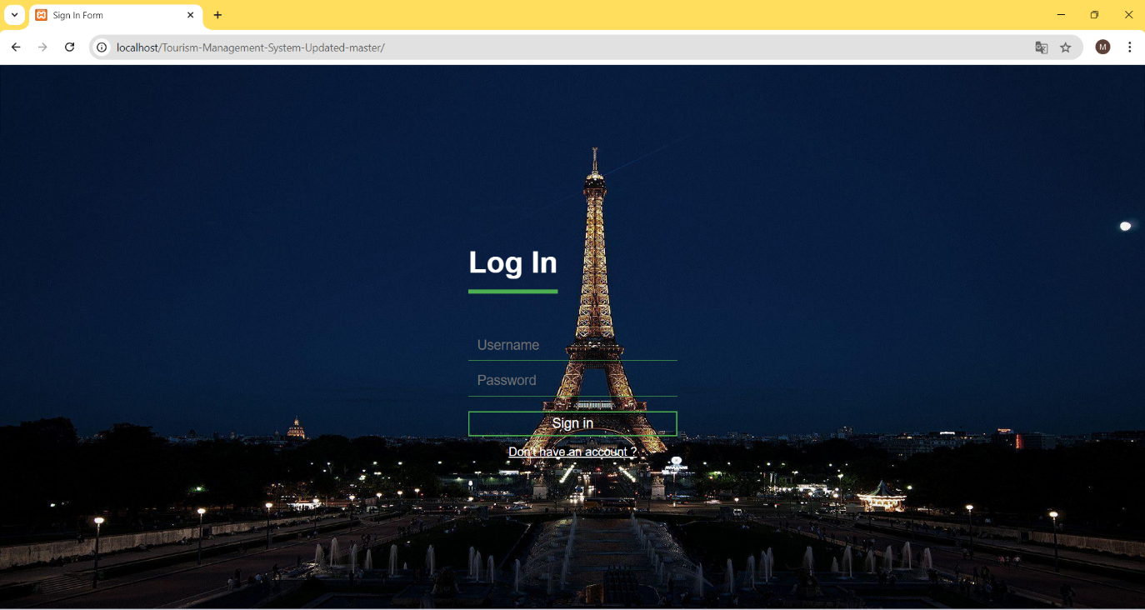

**The user and admin can login from here.**

**Register:**

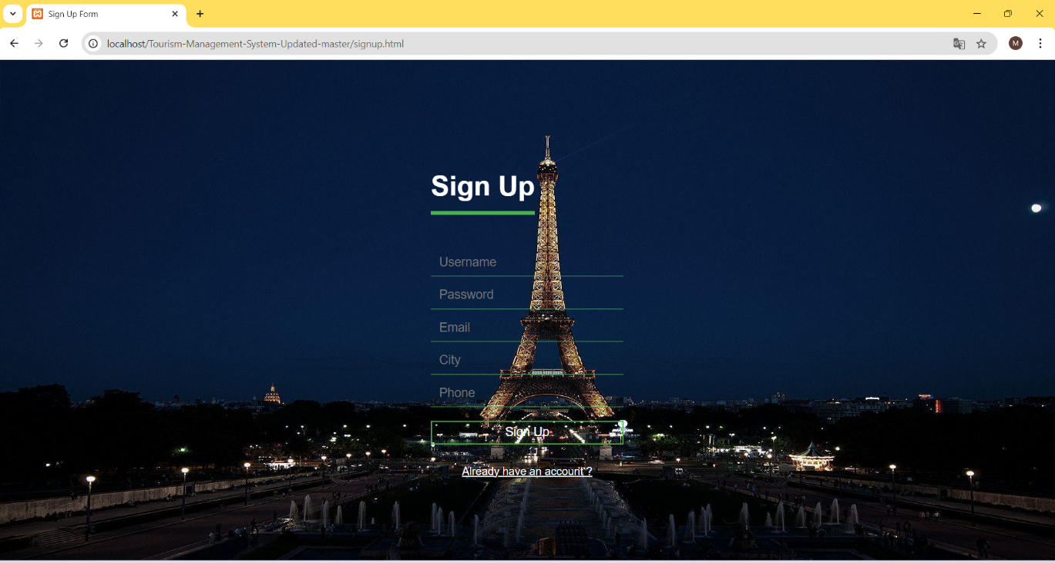

**Registration form for user.**

**Home Page:**

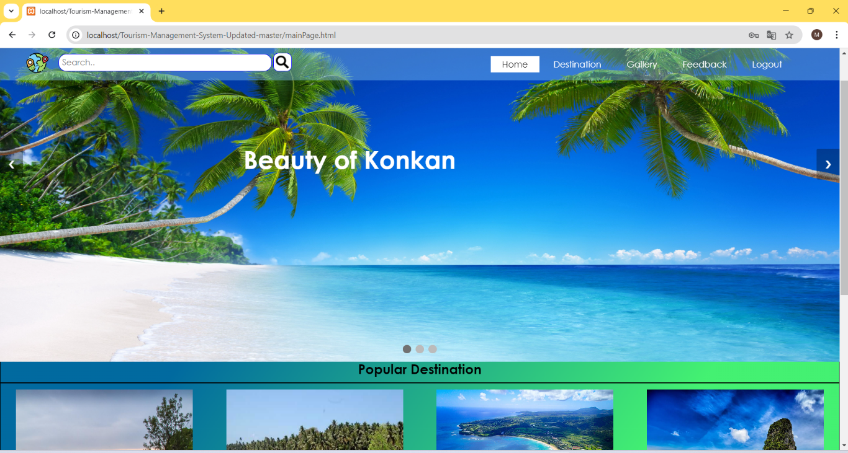

**Home page of Tourism website: Here, user can view updates on recent posts and new places .**

**Destination:**

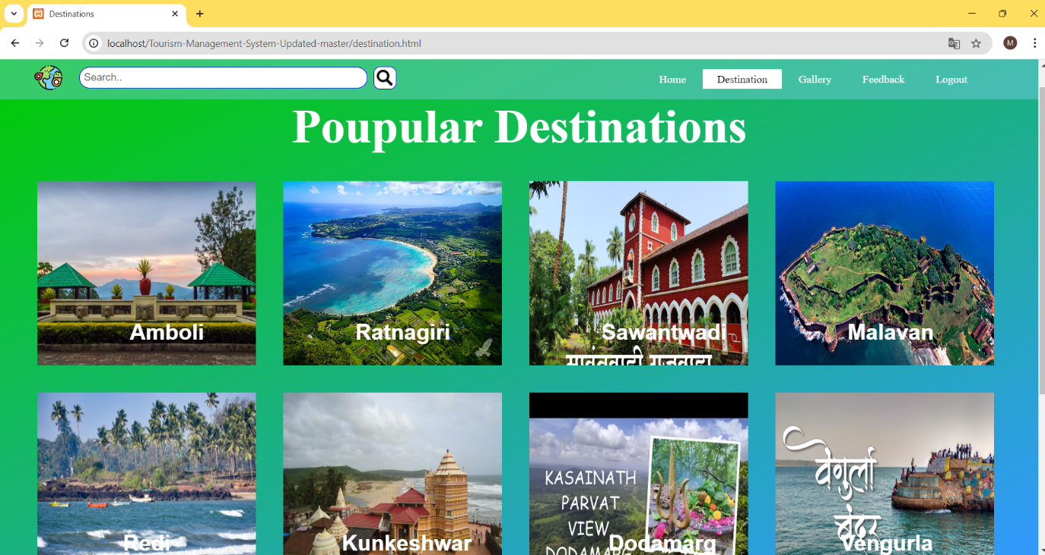

**Destination page: Here, user can see multiple destination in konkan for traveling.**

**Gallery:**

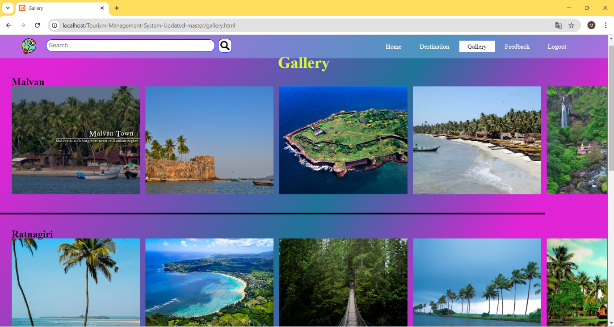

**Gallery:Here, user can see konkan images (temple,water falls, fort, sunset point, beaches,etc.).**

**Place Information:**

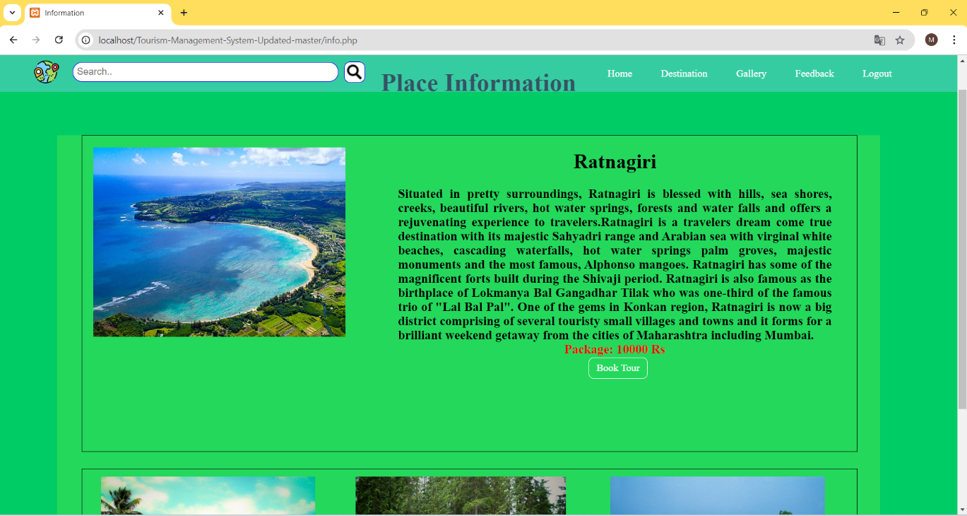

**Place Information: Information about select your destination and those beautiful places.**

**Tour Booking:**

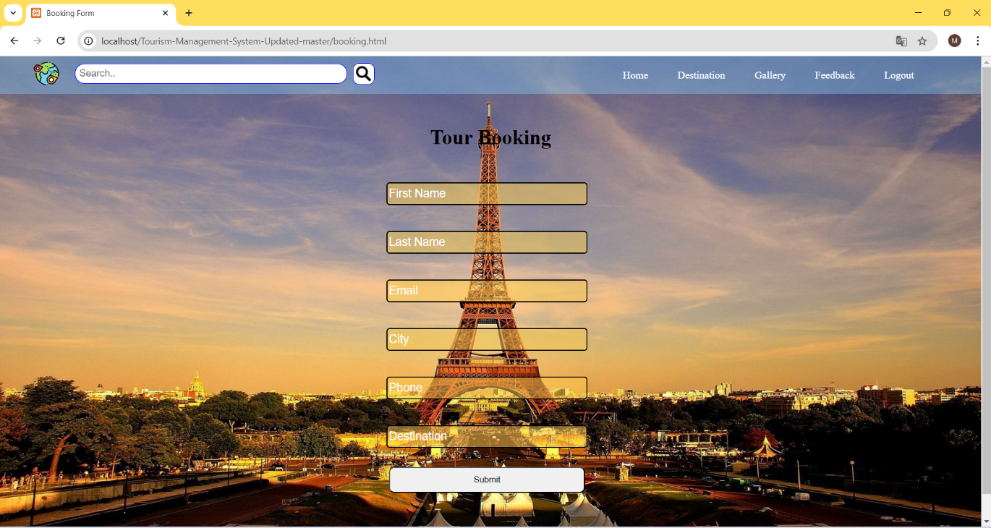

**Tour Booking: here, user can book the tour package in select place.**

**Logout:**

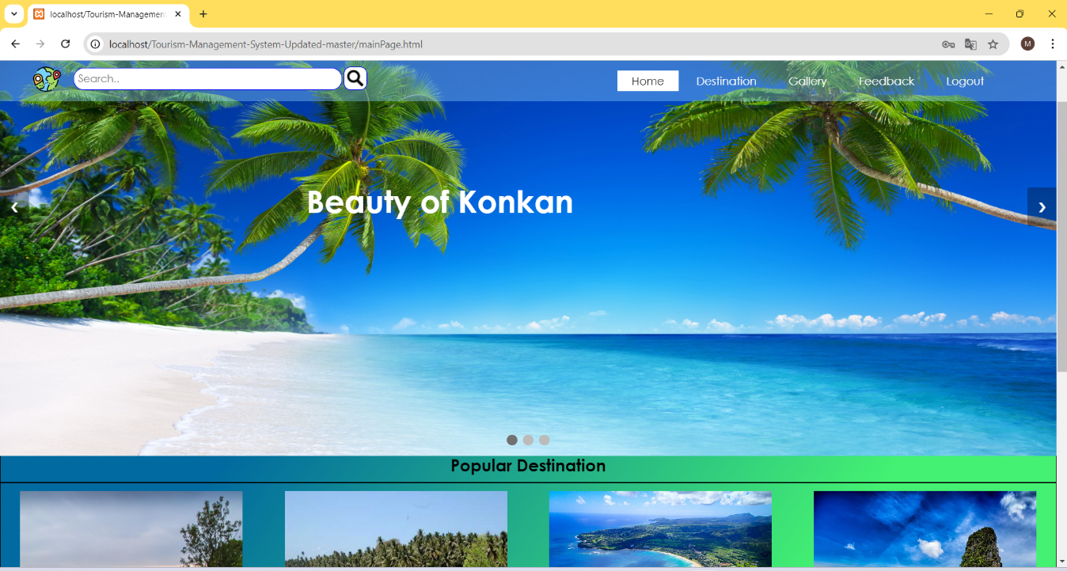

**Logout: user logout the account.**

**5.1.2 Admin View**

**Admin Page:**

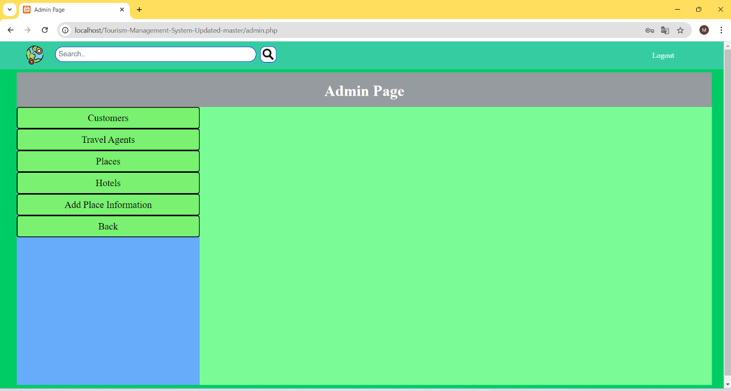

**Admin page , control the admin for all website in this site.**

**Travel Agents:**

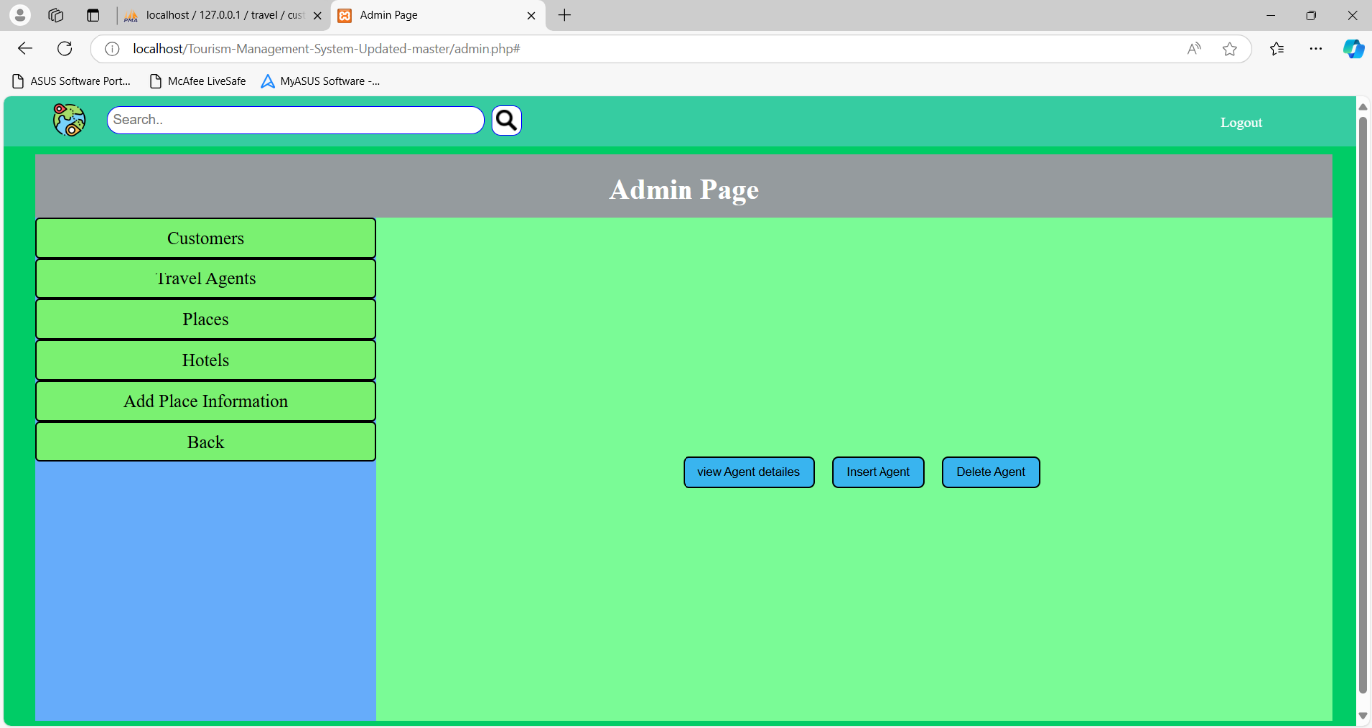

**See the admin, travel agents information. Add the new agent and delete the agent all the operation perform in this page.**

**Places:**

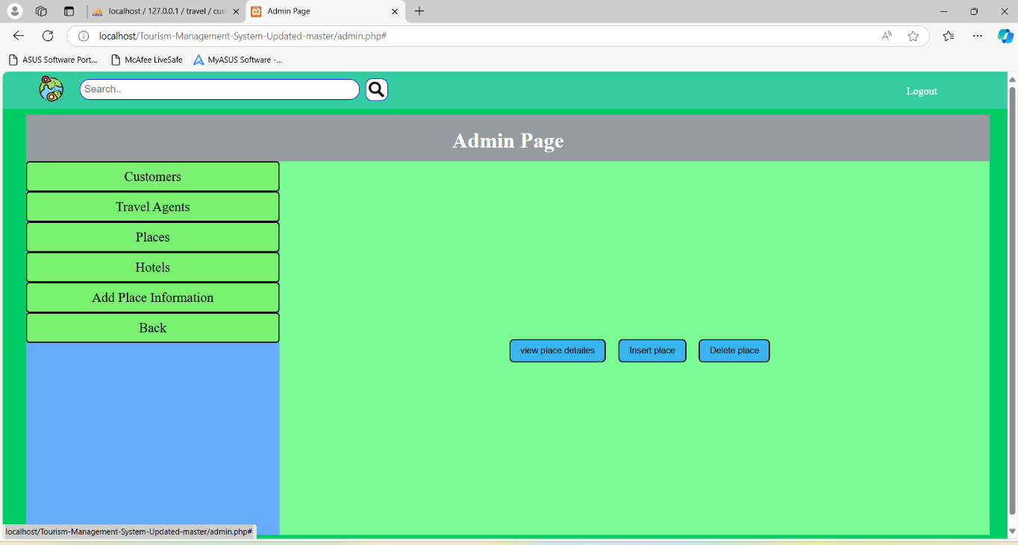

**Admin can see places.(add,delete,view place.)**

**Hotels:**

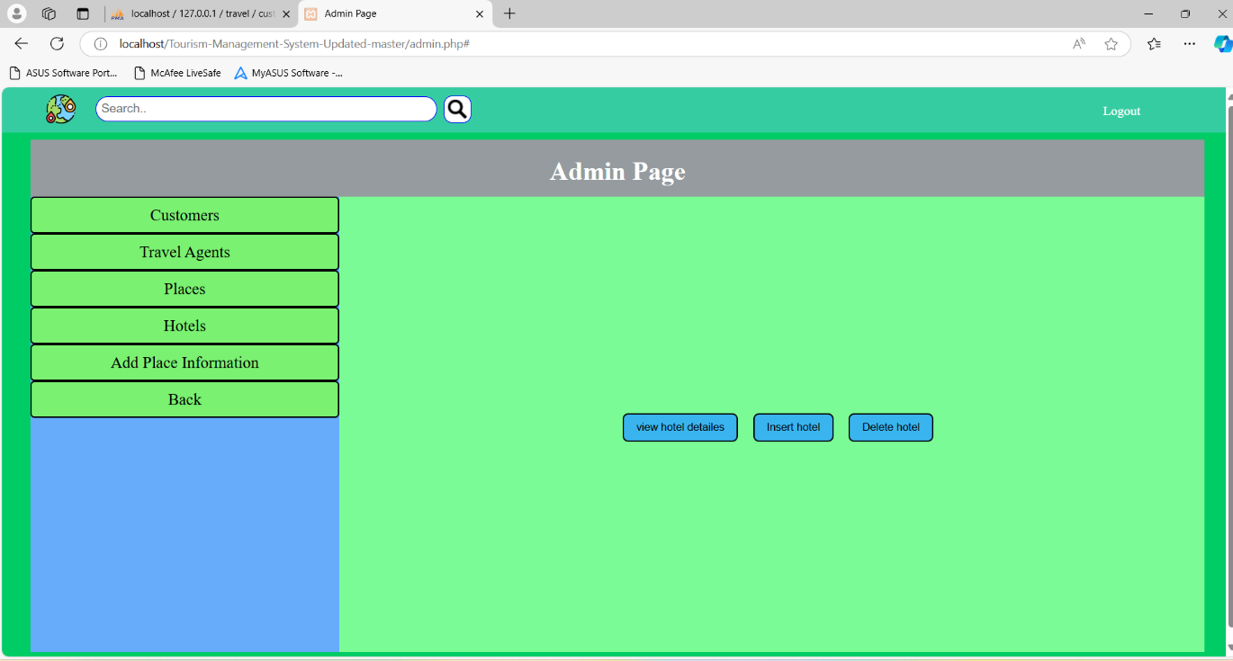

**Add Places Information:**

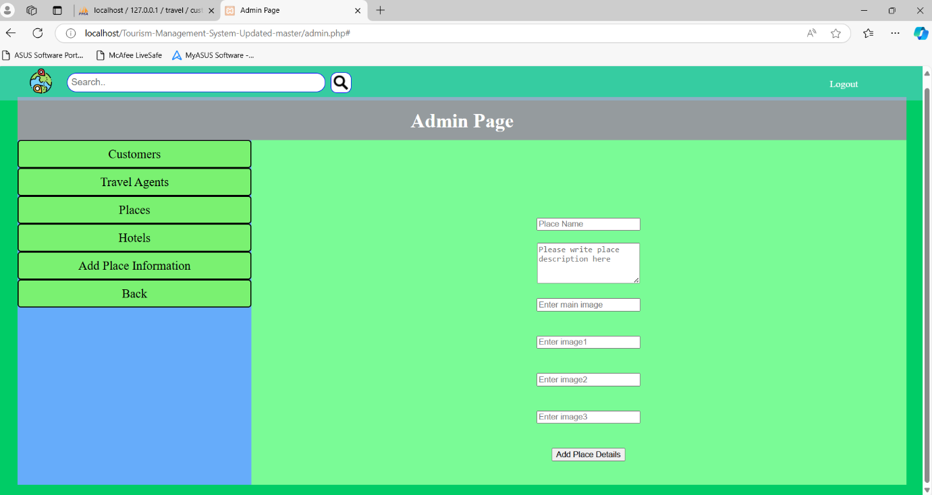

**Admin add and update the places information to see the user**

**Customers :**

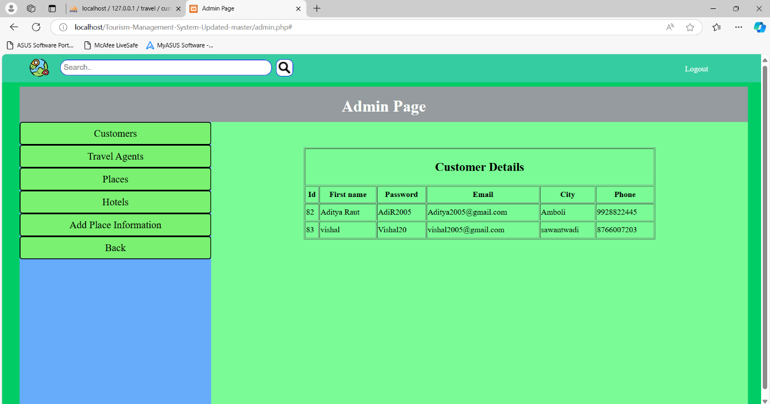

**See the customer list and perform multiple operation(add, delete,etc.).**

**5.1 Coding Details:**

**main.html:**

<!DOCTYPE html>

<html lang="en">

<head>

<meta name="viewport" content="width=device-width, initial-scale=1.0">

<link rel="stylesheet" type="text/css" href="css/style.css">

<style type="text/css">

.signup-op a{

text-decoration: none;

border: 2px solid #000;

background-color: rgba(68,241,154,1);

padding: 8px 20px;

color: black;

transition: 0.8s ease;

}

.signup-op a:hover{

background-color: white;

}

</style>

</head>

<body>

<header>

<div class="slideshow-container">

<div class="mySlides fade">

<img src="front3.jpg" style="width:100%">

</div>

<div class="mySlides fade">

<img src="front2.jpg" style="width:100%">

</div>

<div class="mySlides fade">

<img src="front1.jpg" style="width:100%">

</div>

<div class="main">

<ul>

<ul class="list">

<li class="logo"><a href="mainPage.html"><img src="earth-globe.png" alt="Logo" style="width:36px;height:36px"></a></li>

<div class="search">

<form method="POST" action="info.php">

<input type="text" name="search_p" placeholder="Search.." size="50">

<input type="image" name="submit_p" src="search_icon.png" alt="Search image" style="width:22;height:22; margin-left: 60px; margin-top: 32px;">

</form>

</div>

</ul>

<ul class="list2">

<li class="active-menu"><a href="mainPage.html">Home</a></li>

<li><a id="long" href="destination.html">Destination</a></li>

<li><a href="gallery.html">Gallery</a></li>

<li><a href="feedback.html">Feedback</a></li>

<li><a href="index.html">Logout</a></li>

</ul>

</ul>

</div>

<a class="prev" onclick="plusSlides(-1)">&#10094;</a>

<a class="next" onclick="plusSlides(1)">&#10095;</a>

</div>

</header>

<br>

<div style="text-align:center">

<span class="dot" onclick="currentSlide(1)"></span>

<span class="dot" onclick="currentSlide(2)"></span>

<span class="dot" onclick="currentSlide(3)"></span>

</div>

<div class="title">

<h1><center>Beauty of Konkan </center></h1>

<!-- <div style="margin: 0px 35%;" class="signup-op">

<a href="signup.html">SignUp</a>

<a href="signin.html">SignIn</a>

</div> -->

</div>

<div class="contain" style="border: 1px solid black; height: 500px">

<div class="heading">

<h2>Popular Destination</h2>

</div>

<div class="box">

<div class="imgBox">

<img src="images//destination//Amboli6.jpg" alt="Amboli" style="width: auto;height: 270px;">

</div>

<div class="name-text left1">

<h2>Amboli</h2>

<a href="destination.html" class="btn">Visit</a>

</div>

</div>

<div class="box">

<div class="imgBox">

<img src="images//destination//Malvan1.jpg" alt="Malvan" style="width: auto;height: 270px;">

</div>

<div class="name-text left2">

<h2>Malvan</h2>

<a href="destination.html" class="btn">Visit</a>

</div>

</div>

<div class="box">

<div class="imgBox">

<img src="images//destination//kerala1.jpg" alt="Ratnagiri" style="width: auto;height: 270px;">

</div>

<div class="name-text left3">

<h2>Ratnagiri</h2>

<a href="destination.html" class="btn">Visit</a>

</div>

</div>

<div class="box">

<div class="imgBox">

<img src="images//destination//goa1.jpg" alt="shiroda" style="width: auto;height: 270px;">

</div>

<div class="name-text left4">

<h2>shiroda</h2>

<a href="destination.html" class="btn">Visit</a>

</div>

</div>

<div class="destination-btn">

<a href="destination.html">View all</a>

</div>

</div>

<div class="about">

<h2>Abouts Us</h2>

<footer>

<a href="https://www.facebook.com/"> <img src="images//logo//facebook.png" height="25px" width="25px"> </a>

<a href="https://www.instagram.com/"> <img src="images//logo//instagram.png" height="25px" width="25px"> </a>

<a href="https://twitter.com/"> <img src="images//logo//twitter.png" height="25px" width="25px"> </a>

<p> <b> Posted by:Vishal Parab<br>

Posted by:Kartik Parab<br>

Contact Information: vishalparab2005@gmail.com<br>

Contact Information: kartikparab0108@gmail.com</b></p>

</footer>

</div>

<script>

var slideIndex = 1;

showSlides(slideIndex);

function plusSlides(n) {

showSlides(slideIndex += n);

}

function currentSlide(n) {

showSlides(slideIndex = n);

}

function showSlides(n) {

var i;

var slides = document.getElementsByClassName("mySlides");

var dots = document.getElementsByClassName("dot");

if (n > slides.length) {slideIndex = 1}

if (n < 1) {slideIndex = slides.length}

for (i = 0; i < slides.length; i++) {

slides[i].style.display = "none";

}

for (i = 0; i < dots.length; i++) {

dots[i].className = dots[i].className.replace(" active", "");

}

slides[slideIndex-1].style.display = "block";

dots[slideIndex-1].className += " active";

}

</script>

</body>

</html>

**Signin.php:**

<?php

$db = mysqli_connect('localhost:3306','root','','travel');

$username = $_POST["user"];

$password = $_POST["pass"];

$d = date("Y-m-d h:i:sa");

$i=0;

$usern = "";

$passd = "";

$que="INSERT INTO `login` (`user`,`pass`,`date_time`) VALUES ('$username','$password','$d')";

$sql="SELECT fname, password FROM `customer` WHERE fname='$username' and password='$password'";

$result2 = mysqli_query($db, $sql);

if(isset($_POST['submit'])){

    if($username == 'admin' and $password == 'ad123'){

        $result = mysqli_query($db, $que);

        header('location:admin.php');

    }

    elseif($result2) {

        while($rows = mysqli_fetch_assoc($result2) and $i==0)

        {

            $usern = $rows['fname'];

            $passd = $rows['password'];

            $i= $i+1;

        }

        if ($usern==$username and $passd==$password) {

            $result = mysqli_query($db, $que);

            header("location:mainPage.html");

        }

        else{

            ?>

            <script>

                alert("Invalid username or password");

            </script>

            <?php

        }

    }

}

?>

**feedback.html:**

<!DOCTYPE html>

<html>

<head>

<meta charset="utf-8">

<title>Feedback Form</title>

<link rel="stylesheet" type="text/css" href="feedback.css">

</head>

<body>

<div class="main">

<ul>

<ul class="list">

<li class="logo"><a href="mainPage.html"><img src="earth-globe.png" alt="Logo" style="width:36px;height:36px"></a></li>

<div class="search">

<form method="POST" action="info.php">

<input type="text" name="search_p" placeholder="Search.." size="50">

<input type="image" name="submit_p" src="search_icon.png" alt="Search image" style="width:22;height:22; margin-left: 35px;">

</form>

</div>

</ul>

<ul class="list2">

<li><a href="mainPage.html">Home</a></li>

<li><a id="long" href="destination.html">Destination</a></li>

<li><a href="gallery.html">Gallery</a></li>

<li class="active-menu"><a href="feedback.html">Feedback</a></li>

<li><a href="index.html">Logout</a></li>

</ul>

</ul>

</div>

<div class="feedback">

<h1>Feedback Form</h1>

<form name='feedbackForm' method="POST" action="feedback.php">

<div class="form-group">

<label>Your Name</label>

<input type="text" name="name" class="form-control" id="inputText" placeholder="Your Name" required>

</div>

<div class="form-group">

<label>Your Email</label>

<input type="email" name="email" class="form-control" id="inputEmail" placeholder="Your Email" required>

</div>

<div class="form-group text1">

<label>Feedback:</label>

<textarea class="inputTextarea" name="feedbk" rows="4" class="form-control" ng-model='feedback' placeholder="Please write your Feedback here" required></textarea>

</div>

<div class="wrapper">

<button type="submit" class="btn btn-primary" ng-click="performValidation()" name='submit'>Submit Feedback</button>

</div>

</form>

</div>

</body>

</html>

**CHAPTER 6**

**RESULTS**

**6.1 Test Reports:**

|  |  |  |  |
| --- | --- | --- | --- |
| **Test type** | **Test description** | **Pass/ fail** | **comments** |
| **Functional testing** | **Book photographer functionality** | **pass** | **Able to successfully book photographer** |
| **Performance testing** | **Test under heavy user load** | **pass** | **Website handled expected traffic without performance issues** |
| **Usability testing** | **Test user interface and experience** | **pass** | **UI is easy to navigate and use** |
| **Compatibility Testing** | **Test on different devices and platform** | **pass** | **Website works properly on all tested devices and platform** |
| **Regression testing** | **Test after changes or update** | **pass** | **No new bugs or issues found** |

**CHAPTER 7**

**CONCLUSIONS**

**7.1 Conclusion:**

**7.1.1 Significance of the System:**

The "Beauty of Konkan" tourism website plays a vital role in promoting and enhancing the visibility of the scenic and culturally rich Konkan region. By providing a centralized digital platform, this system aims to:

1. **Promote Konkan Tourism**: The website serves as an informative and user-friendly medium to showcase the diverse tourist attractions of the Konkan region, including its pristine beaches, lush green landscapes, historical sites, and local culture. It highlights unique experiences for both domestic and international travelers.
2. **Ease of Access to Information**: Through detailed descriptions, high-quality images, and interactive features, the website offers tourists easy access to important information such as travel routes, accommodations, local events, and cuisine, thus improving travel planning.
3. **Support for Local Economy**: By increasing the inflow of tourists, the system contributes to the development of local businesses, such as hotels, restaurants, and tour operators, thus promoting sustainable economic growth in the region.
4. **Efficient User Engagement**: The website includes sections for customer feedback, travel itineraries, and FAQs, helping tourists to make informed decisions and feel more connected to the destination. It also enables users to engage with the local culture and heritage through blogs and media content.
5. **Environmentally Conscious Travel**: The system emphasizes eco-friendly tourism by promoting responsible travel practices and raising awareness about preserving Konkan’s natural beauty and resources.

Overall, the "Beauty of Konkan" website serves as a comprehensive guide and a powerful marketing tool to boost tourism, provide valuable insights to visitors, and contribute to the region’s socio-economic and environmental sustainability.

**7.2 Limitations of the System:**

Despite offering a comprehensive platform to explore the beauty of Konkan tourism, the system has certain limitations. One of the primary limitations is its dependency on a stable internet connection, which may hinder user access in remote areas where internet connectivity is weak. Additionally, the system lacks real-time updates and dynamic content such as weather information or live events happening in the region, which could enhance the user experience. The website’s functionality is also restricted to basic informational content and static images, without interactive features such as virtual tours or integrated booking services, which may limit user engagement. Furthermore, the absence of a mobile application version may affect the usability for travelers who rely more on mobile browsing. Future improvements could address these shortcomings by incorporating more advanced features and a mobile-friendly design.

**7.3 Future Scope of the Project:**

* 1. Expansion of Content
* Addition of More Tourist Locations: The website could be expanded to include more unexplored or lesser-known destinations in the Konkan region. Currently, it may focus on popular locations, but future iterations could include hidden gems to attract adventure seekers and travel enthusiasts.
* User-Generated Content: In the future, tourists can contribute by sharing their travel experiences, photos, and reviews. This could be integrated through a user-friendly submission interface.
* 2. Integration of Virtual Reality (VR) and Augmented Reality (AR)
* Virtual Tours: Providing 360-degree virtual tours of popular tourist spots in Konkan can give users a more immersive experience before visiting.
* Augmented Reality Guides: Implementing AR-based features, like scanning landmarks or monuments through a mobile app to receive real-time information, can enhance the tourist experience.
* 3. Multilingual Support
* Regional and International Languages: Adding multilingual options, especially local languages like Marathi and Hindi, and international ones like French or German, would help cater to a broader audience, including international tourists.
* 4. Mobile Application Development
* Native Mobile App: Developing a mobile app for Android and iOS platforms would allow travelers to access information on the go, with offline capabilities, GPS navigation, and real-time updates about local weather, events, and festivals in the Konkan region.
* 5. Booking and Payment Integration
* Travel Bookings: Future versions of the website could partner with hotels, travel agencies, and transport services to allow direct booking for accommodations, car rentals, and guided tours through the website.
* Secure Payment Gateway: Integration of secure payment options for booking accommodations, transport, and other services will streamline the user experience and add convenience for travelers.
* 6. AI-Powered Recommendation System
* Personalized Travel Plans: Using Artificial Intelligence (AI) to analyze user preferences, search history, and demographics to suggest personalized travel itineraries or destinations within Konkan.
* Chatbots for Customer Support: AI chatbots can be integrated to provide real-time customer support, answering frequently asked questions about locations, weather, travel advisories, and other essential travel information.
* 7. Social Media Integration
* Social Sharing Features: Allow users to share their experiences directly on social media platforms like Instagram, Facebook, and Twitter. This can be an effective tool for viral marketing and driving more traffic to the website.
* Influencer Collaborations: Future growth may include collaborations with travel influencers and bloggers to promote Konkan tourism through blogs, videos, and social media posts.
* 8. Eco-Tourism and Sustainable Development Focus
* Sustainable Tourism Practices: The website can include sections promoting eco-friendly tourism in the Konkan region, offering guidelines on responsible travel, eco-friendly hotels, and partnerships with local businesses that support sustainability.
* Volunteer Tourism Opportunities: Incorporating opportunities for tourists to engage in volunteer activities such as beach cleanups or conservation projects can also be part of future updates.
* 9. Interactive Maps and Route Planners
* Custom Travel Routes: Adding interactive maps with customizable travel routes would allow users to plan their trips based on their preferences, such as scenic views, nearby attractions, or cultural spots.
* Public Transport Integration: Provide information about local public transport, including bus and train schedules, as well as ticket booking options directly on the website.
* 10. E-Commerce Integration
* Local Handicrafts and Souvenirs: A future scope could include an e-commerce platform for selling local products, handicrafts, and souvenirs, promoting the artisans of Konkan.
* Affiliate Marketing Opportunities: Collaboration with local businesses and offering affiliate links to hotels, restaurants, and travel services can generate additional revenue.

**References:**

* [**www.Enext.com**](http://www.Enext.com)
* [**www.youtube.com**](http://www.youtube.com)
* [**www.w3School.com**](http://www.w3School.com)
* [**www.stackoverflow.com**](http://www.stackoverflow.com)
* [**www.figma.com**](http://www.figma.com)